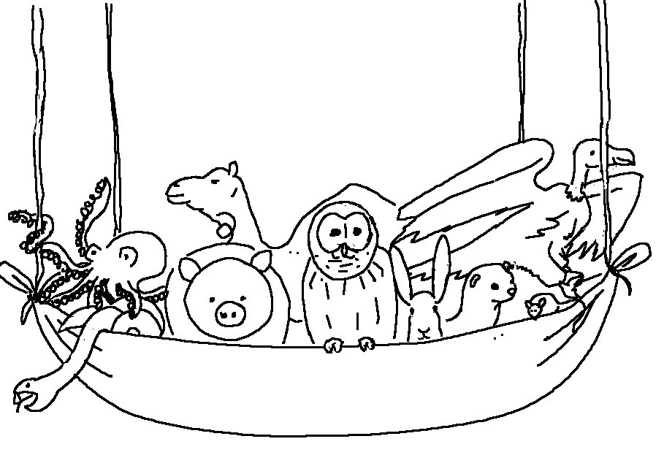
God does not show _ _ _ _ _ _ _ _ _
Acts 10:34 _{NIV}

